Why Do You Need to Know Computer Specifications?

There may be many reasons for needing this information. From needing manufacturers’ information to download the proper drivers for your system all the way to overclocking and knowing a baseline, and maybe, just plain curiosity. There are hordes of measurement tools and specification tools, and bench-marking tools “out there” on the Internet. There are also nearly as many corrupt, wayward souls who would try to steal your money or muck up your computer, or both.

For that reason, and to make your job a little easier, I have put together a short list of utilities that I use and trust.

What to Measure

No matter the reason for needing the information, there are certain common things people want to know. What brand is my Central Processing Unit (CPU), Graphics Processing Unit (GPU), Motherboard (MB), Random Access Memory (RAM)? How fast are they? Do you have the latest drivers? And the list goes on…

CPU & RAM

[](https://davescomputertips.com/wp-content/uploads/2016/06/cpuz-logo.png)CPU-Z is a wonderful utility that will give you all sorts of information, not only about your CPU, but your MB and RAM, too. It is a great source for information that you may need to get the right drivers for your MB. It will also show you CPU clock speeds, Basic Input/Output System (BIOS) information, and much more.

I use it a lot to check RAM timings, too, when, you know,  the “Overclock Fever” sets in?

CPU-Z is free and [portable](https://davescomputertips.com/category/software/portable/)– no installation required. Get your copy at [CPUID](http://www.cpuid.com/softwares/cpu-z.html).

Here are a couple screen grabs to give you a better idea of what to expect:

[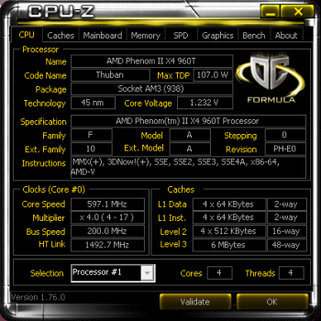](https://davescomputertips.com/wp-content/uploads/2016/06/cpuz-cpu-tab.png)

CPU Tab

[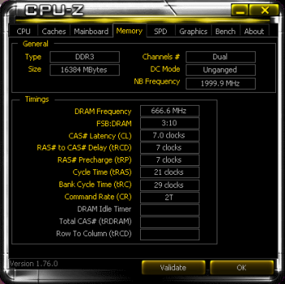](https://davescomputertips.com/wp-content/uploads/2016/06/cpuz-memory-tab.png)

Memory Tab

Note: You can click on the images in this article to see them in their full-sized glory.

GPU

[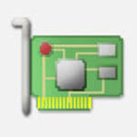](https://davescomputertips.com/wp-content/uploads/2016/06/gpuz-logo.jpg)

GPU-Z, despite it’s similar name, is created by a different developer– namely, TechPowerUp. GPU-Z, like CPU-Z, is free and portable. It focuses, instead, on the GPU, or graphics system in your computer.

Again, here are a couple screen shots for your geeky eyes:

[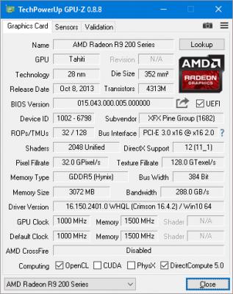](https://davescomputertips.com/wp-content/uploads/2016/06/gpuz-graphics-card-tab.png)

GPU Tab

[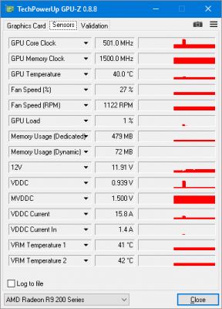](https://davescomputertips.com/wp-content/uploads/2016/06/gpuz-sensors-tab.png)

Sensors Tab

Sometimes, if I need to see [what is](https://davescomputertips.com/category/whatis/) causing bottleneck problems, it is very handy to watch the Sensors Tab. You will be able to see what type of stress is being imposed on your graphics system. If you’d like to grab a copy for yourself, go to [TechPowerUp](http://www.techpowerup.com/gpuz/).

Hard Disk Drives and Solid State Drives

[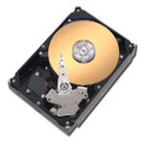](https://davescomputertips.com/wp-content/uploads/2016/06/hdtune-logo.jpg)I like HDTune. There are many features included in the program to check drive speeds, health, temperature, and even an option to perform a secure “wipe” (read “data deletion”). That’s very handy if you want to be sure your drive is free of personal information before selling or donating it.

Unlike the previous two utilities, this program will need to be installed. Also, there is a Free version and a Pro Version.

Pro Version

At the time of this writing, the Pro version is going for $34.95 (US). HDTune offers a free trial period so you can try-before-you-buy. There is also a side-by-side comparison of the two versions to help you make an intelligent decision.

Free Version

The Free version can be used indefinitely for personal use only. When you get to the HDTune web site, you’ll have to scroll down the page about half-way. Look for the information in the following image:

[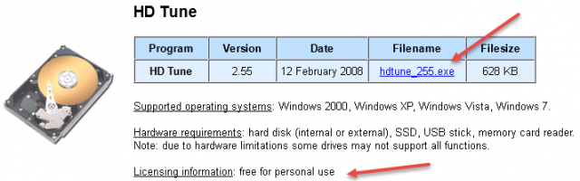](https://davescomputertips.com/wp-content/uploads/2016/06/hdtune-download-image.png)

Here’s a screen shot to tantalize your graph-starved mind:

[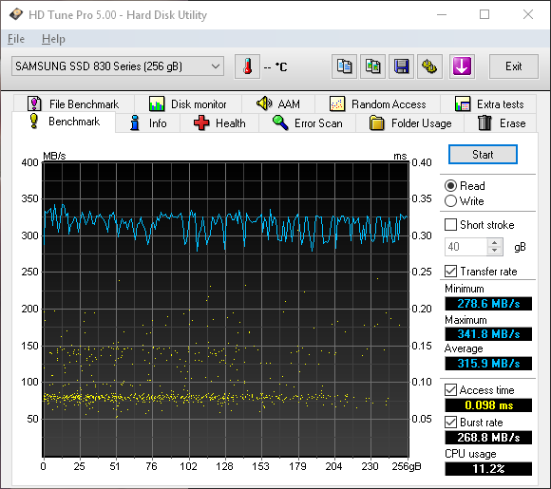](https://davescomputertips.com/wp-content/uploads/2016/06/hdtune-read-test.png)

HDTune after performing a Read Test on Solid State Drive (SSD)

Here’s the link to the [HDTune Download Page](http://www.hdtune.com/download.html) that you’ve all been waiting for.

All Specs in One Place

[](https://davescomputertips.com/wp-content/uploads/2016/06/speccy-logo.png)Speccy! This is one very cool utility provided by the well-trusted creators of CCleaner, Piriform. Speccy will need to be installed but is well worth it if you want to know more than you thought you’d ever want to know.

Update: The Speccy Portable version can be downloaded on this [Builds Page](http://www.piriform.com/speccy/builds). Thanks to our sharp-eyed reader, o2bys.

While running Speccy, I checked its information against what I know, in the real world, that is. As far as I can see, it was totally accurate with a couple exceptions– the CPU and drive temperatures.

With a reported idle CPU temperature of 29 degrees Centigrade, using a stock cooler, I’d be the envy of the world’s tech community. Sorry, but it’s off by about 10 degrees.

[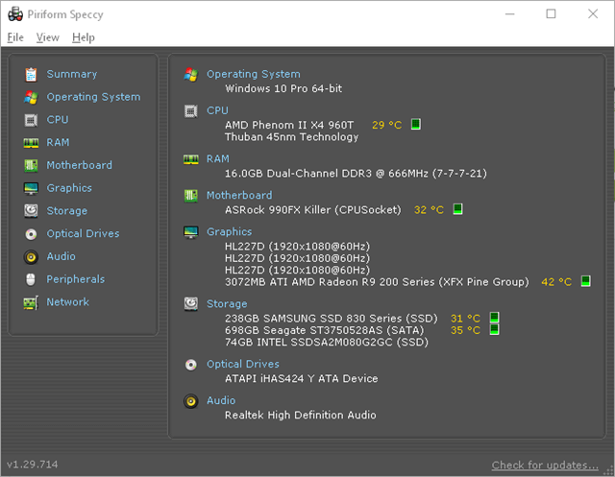](https://davescomputertips.com/wp-content/uploads/2016/06/speccy-start-page.png)

Speccy Start Screen

This is not a problem specific to Speccy, however. For whatever reason, every single CPU temperature monitor I have ever used on this motherboard shows that same temperature offset.

For a short time, I was ecstatic when I thought my computer was running state-of-the-art [games](https://davescomputertips.com/category/software/games/) at 39 degrees under tremendous load. After the euphoria broke, and I got suspicious of these remarkable numbers, I am still happy to report that 49 degrees is not a bad number. Pretty good, actually 

Thanks, clas, for showing me the error of my ways.

All I’m saying here is to take the temperature reports with a grain of salt. Either Speccy, or my motherboard, is off its little electronic rocker. I suspect the latter.

Speccy is a very useful utility and you can get your copy at this [Piriform/Speccy Download Page](http://www.piriform.com/speccy).

Final thoughts

Knowing how your computer works and knowing its specifications can be a tremendous boon to your interactions with it. Especially, if it breaks. If you are armed with all the current information, you will be much better equipped to deal with any future problems.

“I can not function efficiently without all the information” ~ Bugsy

With that in mind, the aforementioned tools should go a long way towards helping to nudge you in that most positive of directions.

Further reading: [Peeking Under the Hood: System Information & Monitoring Tools](https://davescomputertips.com/peeking-under-the-hood-system-information-monitoring-tools/)

Richard

—–

You May Also Like

[Over-clocking – A Tempting Offer](https://davescomputertips.com/over-clocking/)

[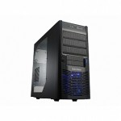Three Things to Look for When Buying a Case for Your Gaming Computer](https://davescomputertips.com/three-things-to-look-for-when-buying-a-case-for-your-gaming-computer/)

[Let’s Build a Retro PC – Part 2](https://davescomputertips.com/lets-build-a-retro-pc-part-2/)

[My Top 5 PC product peeves!](https://davescomputertips.com/my-top-5-pc-product-peeves/)

[How to Determine GPU vs CPU Bottlenecks and Possible Solutions](https://davescomputertips.com/how-to-determine-gpu-vs-cpu-bottlenecks-and-possible-solutions/)

[Cry For Me Argentina](https://davescomputertips.com/cry-for-me-argentina/)

[Load more posts[https://wprp.zemanta.com/static/img/loading.gif](https://davescomputertips.com/how-to-know-your-computer-specifications/?utm_source=wysija&utm_medium=email&utm_campaign=Weekly+Recap+Newsletter)](https://davescomputertips.com/how-to-know-your-computer-specifications/?utm_source=wysija&utm_medium=email&utm_campaign=Weekly+Recap+Newsletter)

Posted in:

[Computer Hardware](https://davescomputertips.com/category/hardware/)

[How-To](https://davescomputertips.com/category/how/)

Tagged with:

[hardware](https://davescomputertips.com/tag/hardware-2/)

[monitoring tools](https://davescomputertips.com/tag/monitoring-tools/)

See more

Prev:[Create Compound Characters in Word](https://davescomputertips.com/create-compound-characters-in-word/)

Back:[All Posts](https://davescomputertips.com/" \o "See all entries)

Next:[How to Create Highlights Video On Twitch](https://davescomputertips.com/how-to-create-highlights-video-on-twitch/)

About the Author

[Richard Pedersen](https://davescomputertips.com/author/richard-pedersen/)

https://secure.gravatar.com/avatar/54dd00ccbb8ff2e1b275414b0b7b0cc2?s=60&d=retro&r=r

Richard received his first computer, a C-64, in 1982 as a gift and began dabbling in BASIC. He was hooked! His love for computing has led him from the old “XT” boxes to the more modern fare and from clunky 10MB hard drives to smooth and fast modern day SSD drives. He has run BBS services, Fido mail, and even operated his own computer repair business.